How to add a user to a Chromebook

Once you’ve turned on the Chromebook, click on “Add Person” at the lower left of your screen.

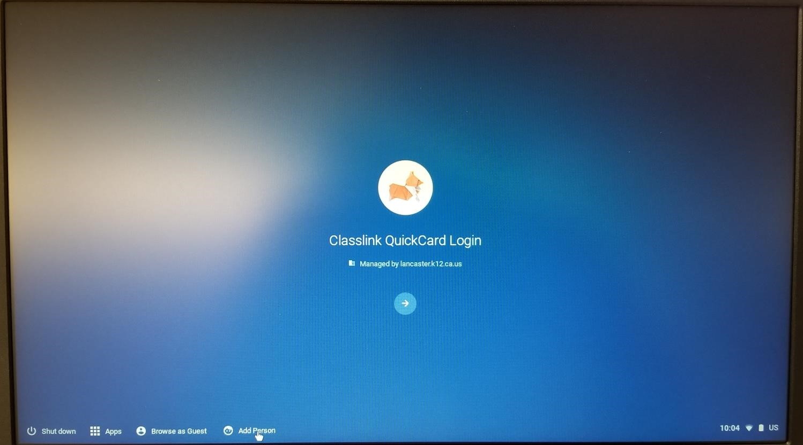

Type student username (e.g. first name, last initial, last 4 of student ID (milenac9805) - used daily at school) & click next.

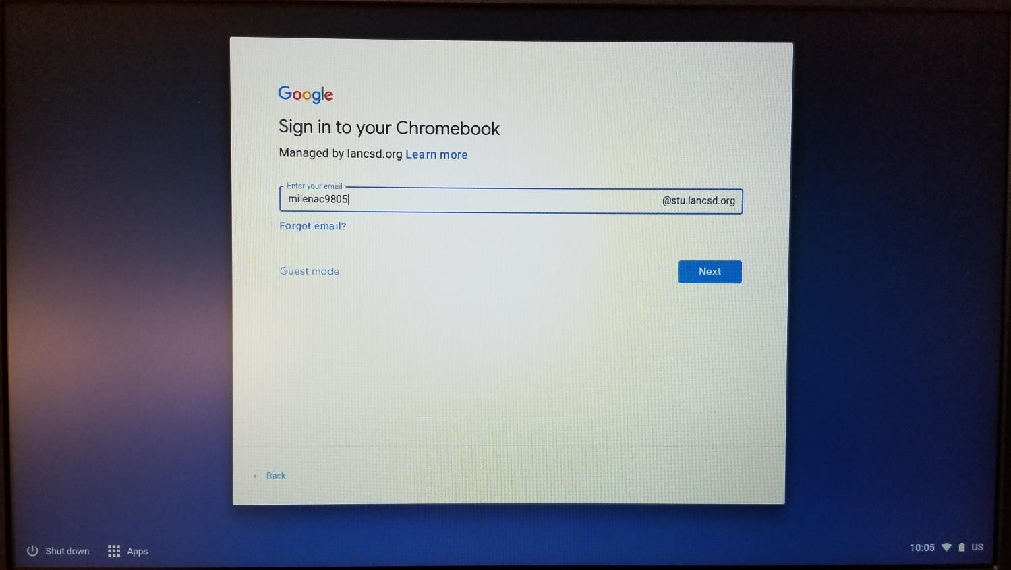

Type student password (used daily at school) & click next

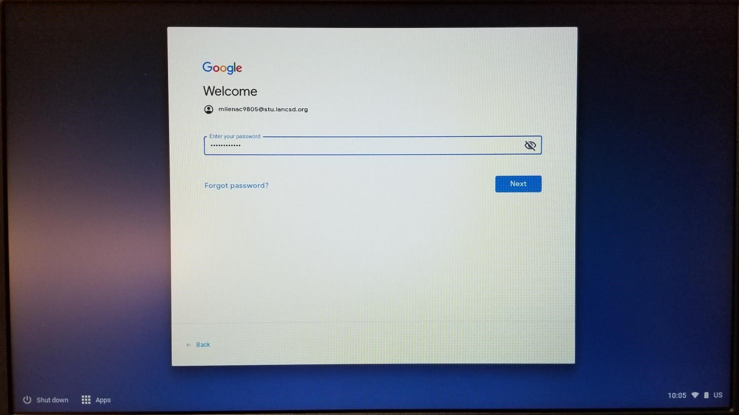

At this point, the student will be logged in and will see their desktop.

